Earth Science Revision
1. Label the layers of the Earth on the diagram below.
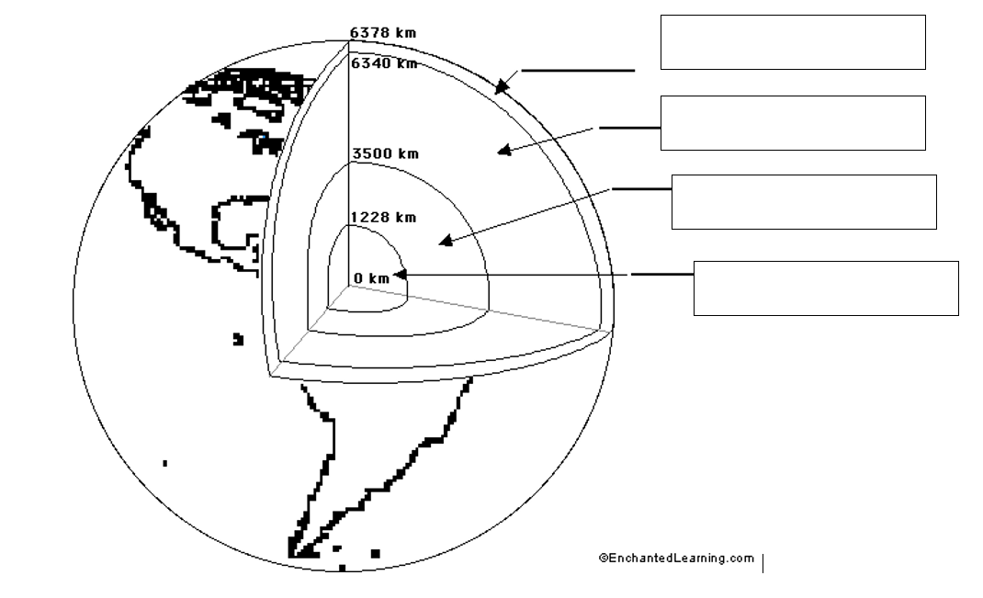
2. Which of the layers of the Earth is:
a) the thickest d) liquid
b) the hottest e) solid
c) mainly iron and nickel f) thinnest
3. Name the two types of crust, and describe the main characteristics of each type. (eg: location, density, rock composition, thickness)
4. Label the map below with the names of the major plates:
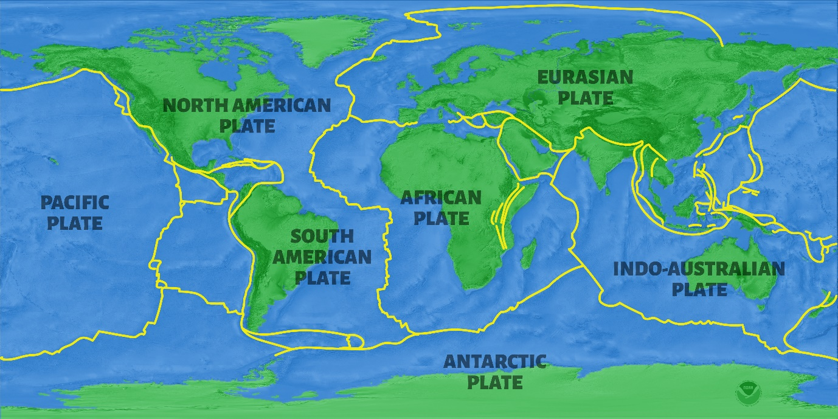
5. Name the scientist who first proposed that the continents moved, and name his theory.
6. Describe at least 2 types of evidence that supports the theory of plate tectonics.
7. Identify the source of heat that drives plate tectonics.
8. Explain the movement of tectonic plates with reference to heat energy and convection currents.
9. Explain the process of sea floor spreading
10. Explain the process of subduction
11. Name the three types of plate boundary shown in the diagram below.
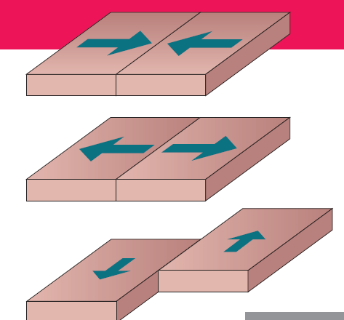
12. Describe plate boundaries where the following may occur:
a) subduction
b) ocean trenches
c) fold mountains
d) rifting under the sea
e) an ocean trench next to a continental mountain range
f) earthquake
13. At diverging boundaries, seafloor spreading is occurring as new crust is continually created. Explain why the Earth’s crust overall is not getting any bigger.
14. Use the theory of plate tectonics to explain why most earthquakes and volcanoes occur near plate boundaries.
15. Explain why is Australia considered to be a very geologically stable country.
16. Distinguish between the focus and the epicentre of an earthquake
17. Australia is moving northward at a rate of approximately 5cm per year. Determine how far will it move in an average human lifetime (approx. 80 years).
18. Classify the three types of plate boundaries (transform, converging and diverging) as being either constructive, destructive or conservative, and explain why they are classified this way.

19. Figure 2.2.9 shows part of a spreading boundary underneath the ocean. Identify which rock would be the same age as rock b, and explain how you know.
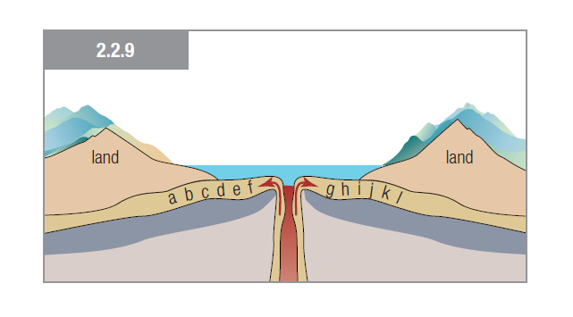
20. Complete the table below to summarise the different types of plate boundaries:
Plate Boundary | Diagram | Description | Landforms
Divergent
Convergent Subduction plate boundaries
Oceanic vs Continental plates
Convergent Collision plate boundaries
Continental vs Continental Plates
Transform plate boundaries

21. Define the following terms:
Continental Drift Ocean Trench Plate tectonics Seafloor spreading Subduction
Continental crust Converging boundary Diverging boundary Oceanic Crust Focus
Transform boundary Epicentre Earthquake Magma Seismic wave Volcano
Hot spot P wave S wave Tsunami Seismometer Plate tectonics
